TOWN OF THORNTOWN
TOWN COUNCIL MEETING
June 3, 2024
7:00 PM

The June 3, 2024, meeting of the Council of the Town of Thorntown was called to order by Council President, Sara Fairfield, at 7:00 pm. The meeting was held at the Thorntown Town Hall, 101 W. Main St., Thorntown, IN. The Council and citizens joined together in reciting the Pledge of Allegiance.

The following were in attendance:

Sara Fairfield, Council Frank Clark, Marshall
Bruce Burtner, Council Colin Sullivan & Chris Wheatly - BFS
Larry Truitt, Council 2 citizens
Dave Williams, Council
Shawn McClintock, Council
Koren Gray, Clerk/Treasurer

Presentations/Guests:
BFS Engineering presented an option for repairing the stormwater that stands in the alley west of the Pizza King. The alley has a high point in the middle of the alley. The option would be to remove asphalt and replace with concrete due to the small area and have an inverted crown. The engineer does have a concern with the downspouts going into the ground. An estimated cost for this project would be $44,540.00. Shawn made a motion to allow BFS to send out for bids not to exceed the $44,540. Bruce made a second. Motion passed 5-0.

Public Comments/Concerns:
None

Public Hearing:
Sara opened the public hearing at 7:27 pm and read Resolution 2024-4, Additional Appropriations. The additional appropriations are: 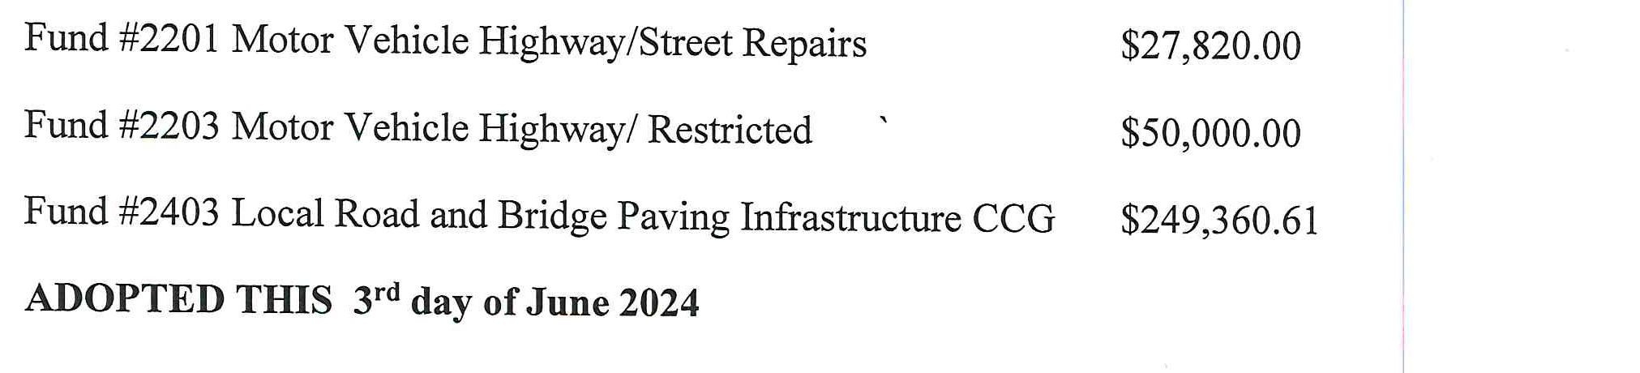
With no questions from the public, Shawn made a motion to close the public hearing at 7:30 pm. Sara made a motion to approve Resolution 2024-4. Shawn made a second. Motion passed 5-0.

Department/Board and Commissions Reports:
(NO REPORTS THE FIRST MONDAY OF THE MONTH MEETING)

Police: (Report previously submitted to Council) The Clerk/Treasurer asked the Council if we could pay for half of the new police vehicle from our savings portion of LIT Public Safety. Bruce made a motion to pay 50% of the 2023 Ford from the town savings portion and 50% from the Police account portion. Shawn made a second. Motion passed 5-0.

Fire:
Advisory Planning Commission:
Building Inspector:
Utility Department:
Park Board:
Storm Water Board:
Sanitary Sewer:

Customary Items for Approval:
Minutes from May 20, 2024 – Bruce made a motion to approve minutes as written. Larry made a second. Motion passed 5-0.

Clerk/Treasurer:
The Clerk/Treasurer provided the 2025 Budget Schedule. The CT would like to discuss using ARPA Funds for paying health premiums and use the General Funds for the Makeover 180 Grant. There are federal guidelines we need to follow if we use the ARPA grant funds. The CT would also like to discuss health coverage options for the upcoming renewal in November.

Unfinished Business:

Lagoon Fencing – table
RDC appointments – continued
Council Policy and Procedures – table until June 17
Sanitary Hot list – table
Trash Clean-up Day. Shawn is also having difficulty finding a vendor to help with Town Clean-Up Day. The Park Board offered a name of a vendor, Priority Waste.
Might E Hauling Sweeper - table

New Business:
Drew, Gary and Koren researched for fire extinguishers and first aids kits for all town owned vehicles. Our insurance carrier is requesting we have these items in each vehicle.

Other Business:
The Sugar Creek Art Center is wanting to put up a sign on the corner of Main and Pearl. They are asking if they need a new permit. The Council advised they may piggy back off the existing permit for signage.

Adjournment:

With no other business to be presented, Dave made a motion to adjourn the meeting at 8:42 pm. Larry made a second. Motion passed 5-0.

____________________________________ ___________________________________
Sara Fairfield Koren Gray
Council President Clerk/Treasurer

Date ________________________________

